**ASSISTED PRACTICE (JMETER CONTROLLERS USING SELENIUM)**

Random Controller:

Step1: Record some steps using blazemeter of Heroku app

Step2: Then, Open this recorded file in Jmeter

Step3: Right click on Thread Group -> Add -> Logic controller -> Add three Simpler controllers

Step4: Make separate simple controllers for all of the recorded steps

Step5: Right click on Thread Group -> Add -> Logic controllers -> Random controller (Place all the clicking steps of heroku app that we perform inside this controller) and Two simple controllers (one for login step and one for logout step)

Step6: In Thread Group -> Give the Number of users as “3”

Step7: Right click on Thread Group -> Add -> Listener -> View Results tree

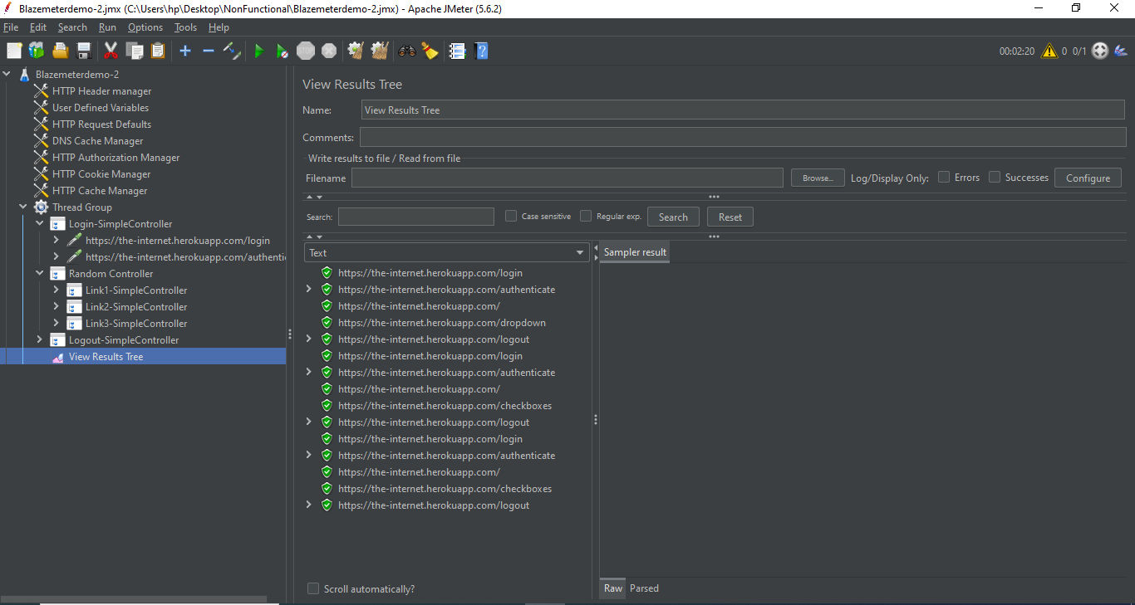

Random order Controller:

Step1: Record some steps using blazemeter of Heroku app

Step2: Then, Open this recorded file in Jmeter

Step3: Right click on Thread Group -> Add -> Logic controller -> Add three Simpler controllers

Step4: Make separate simple controllers for all of the recorded steps

Step5: Right click on Thread Group -> Add -> Logic controllers -> Random order controller (Place all the clicking steps of heroku app that we perform inside this controller) and Two simple controllers (one for login step and one for logout step)

Step6: In Thread Group -> Give the Number of users as “1”

Step7: Right click on Thread Group -> Add -> Listener -> View Results tree

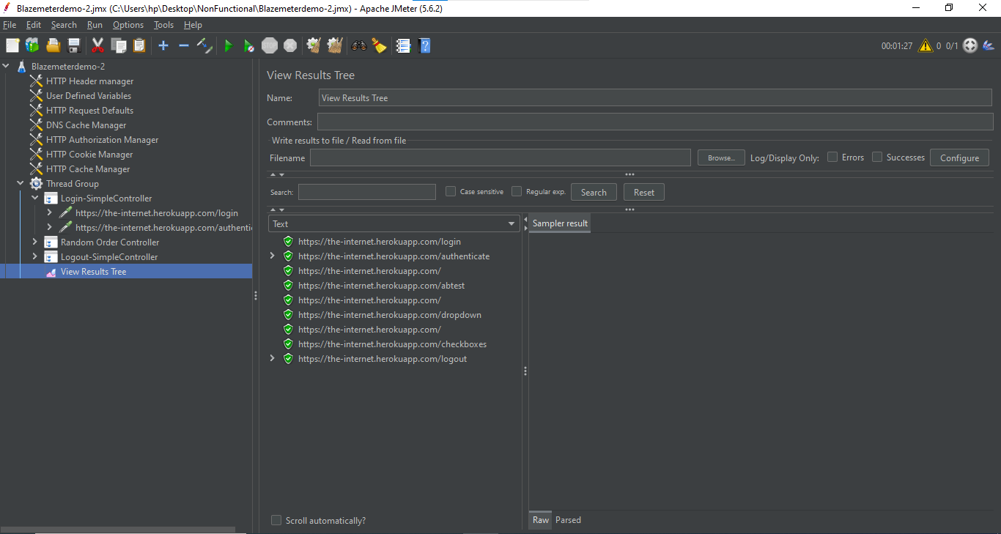

Switch Controller:

Step1: Record some steps using blazemeter of Heroku app

Step2: Then, Open this recorded file in Jmeter

Step3: Right click on Thread Group -> Add -> Logic controller -> Add three Simpler controllers

Step4: Make separate simple controllers for all of the recorded steps

Step5: Right click on Thread Group -> Add -> Logic controller -> Switch Controller

Step6: In Switch controller, Give switch value as one of the sampler

Step7: Right click on Thread Group -> Add -> Listener -> View Results tree

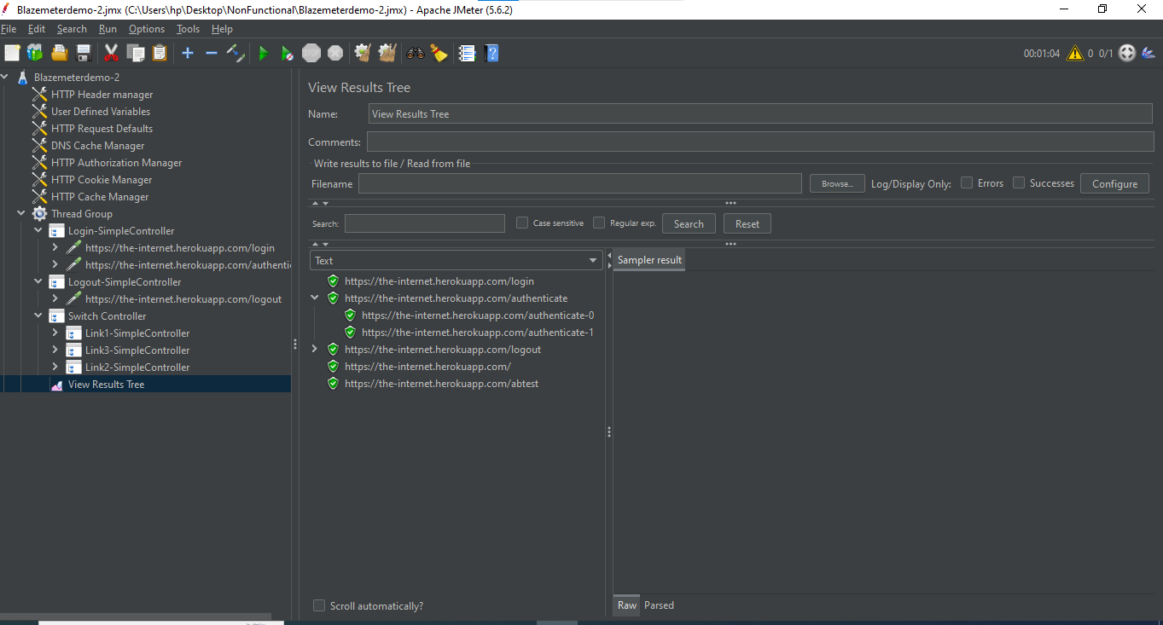

Interleave Controller:

Step1: Record some steps using blazemeter of Heroku app

Step2: Then, Open this recorded file in Jmeter

Step3: Right click on Thread Group -> Add -> Logic controller -> Add three Simpler controllers

Step4: Make separate simple controllers for all of the recorded steps

Step5: Right click on Switch controller -> Change controller -> Logic controller -> Interleave controller

Step6: Right click on Thread Group -> Add -> Listener -> View Results tree

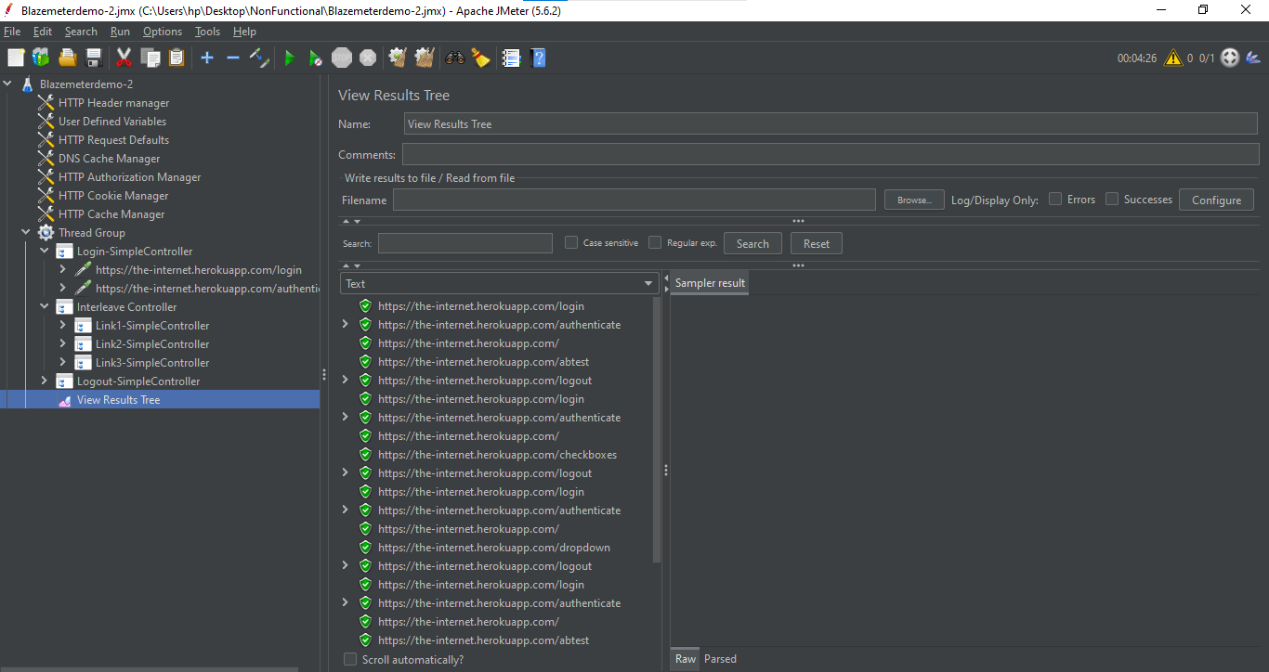

Module Controller:

Step1: Open the Blazemeterdemo-2 Script in Jmeter

Step2: Disable the controllers that we previously added in this Script

Step3: Right click on Thread Group -> Add -> Logic controller -> Module Controller

Step4: Click on Module Controller -> It displays all our scripts and disable controllers of Thread Group -> Select any one of the disable controller that we want to run as shown below:

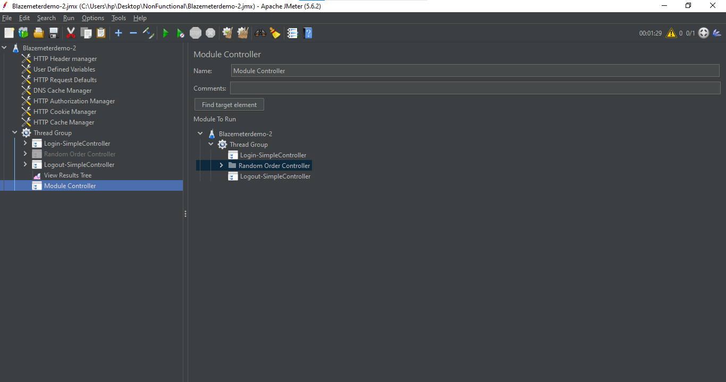

Step5: Right click on Thread Group -> Add -> Listener -> View Results Tree (to see the output )

Step6: Save it and execute

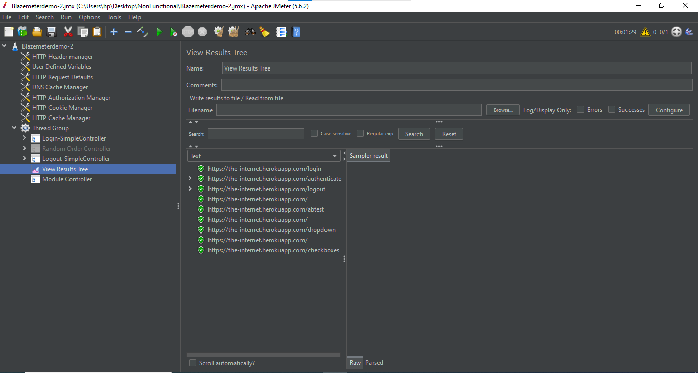

Include Controller:

Step1: Open new Test Plan in Jmeter and Save this plan in folder

Step2: Right click on Test Pan -> Add -> Test Fragment -> Test Fragment

Step3: Right click on Test Fragment -> Add -> Sampler -> HTTP Request

Step4: In HTTP Request, Give the details as shown below:

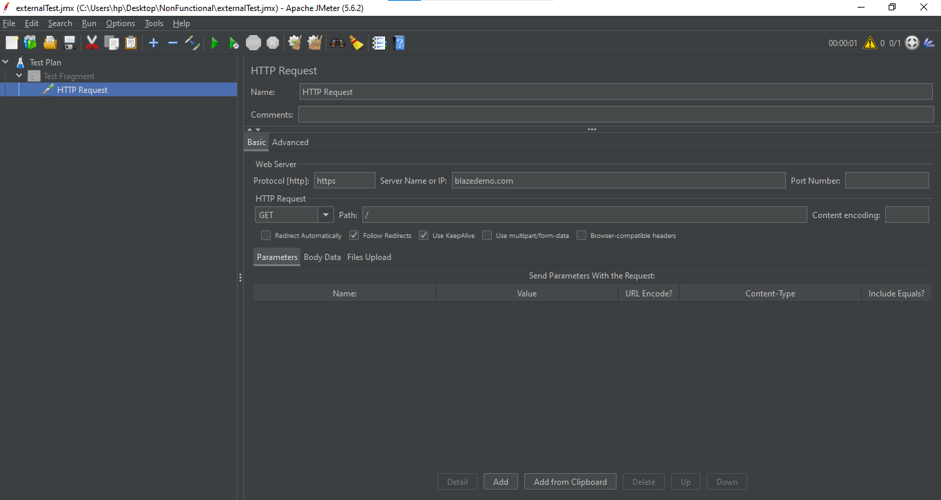

Step5: Open the Blazemeterdemo-2 Script in Jmeter

Step6: Create another Thread Group for Include Controller in that script

Step7: Right click on Thread Group -> Add -> Logic controller -> Include Controller

Step8: In Include Controller, Give the whole path of above file in Filename Section as shown below:

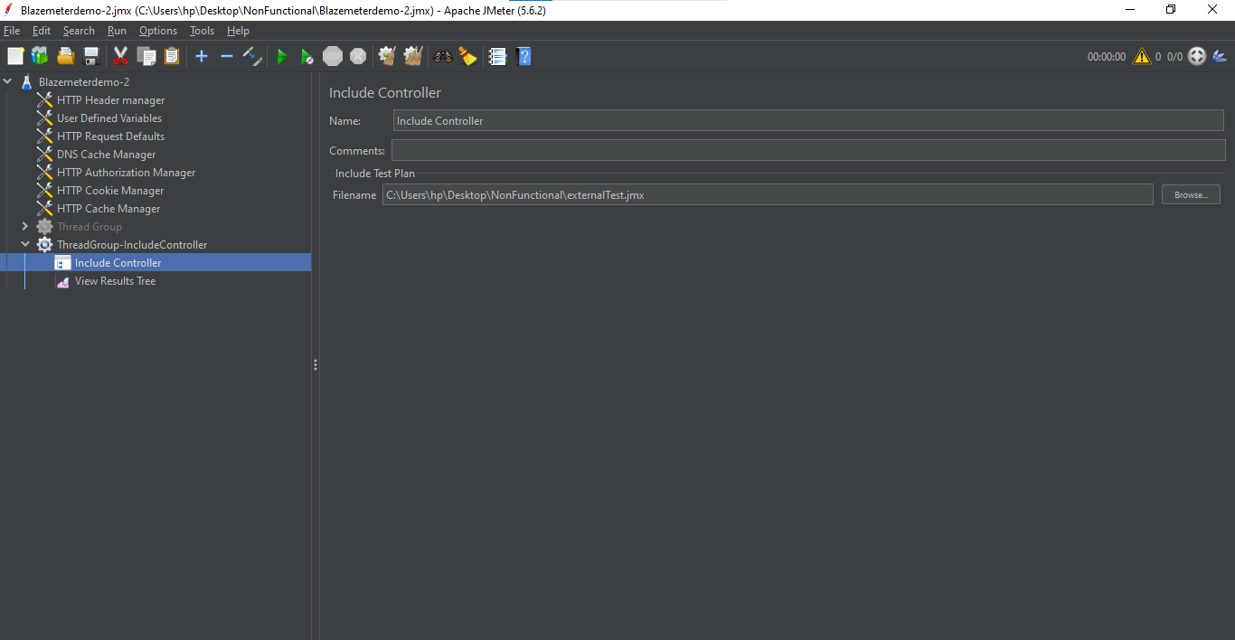

Step9: Right click on Thread Group -> Add -> Listener -> View Results Tree (to see the output)

Step10: Save it and execute

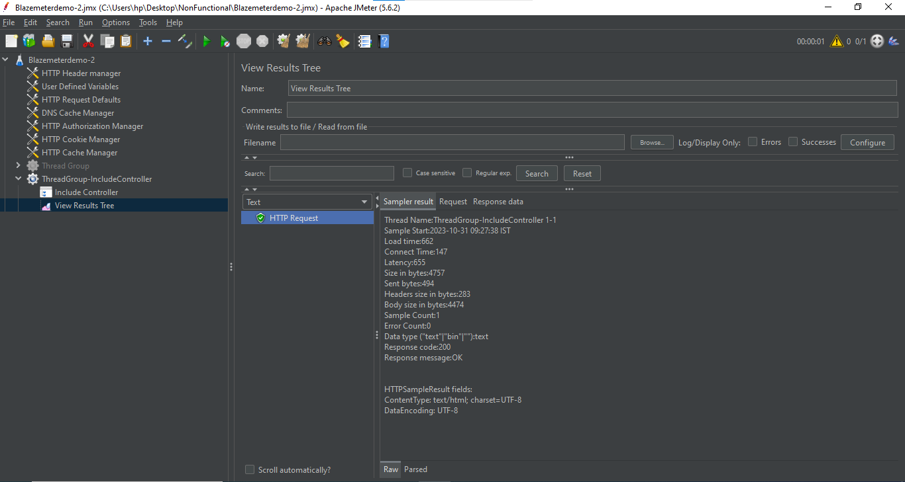

For Each Controller with Regular Expression Extractor:

Step1: Open Jmeter -> Add Thread Group

Step2: Right click on Thread Group -> Add -> Sampler -> HTTP request

Step3: In HTTP request, Give “https” as Protocol, Give “blazedemo.com” as Server, Give “/” as Path

Step4: Right click on HTTP request -> Add -> Post Processors -> Regular Expression Extractor

Step5: In Regular Expression Extractor, Give “city” as Name of created variable, Give “<option value="(.*?)">(.*?)</option” as Regular Expression, Give “$1$” as Template, Give “-1” as Match Number, Give “City not Found” as Default value

Step6: Right click on Thread Group -> Add -> Logic Controller -> For Each Controller

Step7: In For Each Controller, Give “city” as Input variable prefix, Give “1” as Start index for loop, Give “${city_matchNr}” as End index for loop -> Give “eachCity” as Output variable name

Step8: Right click on For Each Controller -> Add -> Sampler -> Dummy Sampler -> Give the name of Dummy Sampler as “The city name is -${eachCity}” (To install the Dummy Sampler -> Go to options of Jmeter -> Click On Plugin manager -> Available plugins -> Search for Dummy Sampler and install it(select the checkbox) -> Once it has been installed, Click on “Apply changes and restart jmeter” at the bottom of this window -> Jmeter will restart )

Step9: Right click on Thread Group -> Add -> Listener -> View results tree (to see the output)

Step10: Right click on Thread Group -> Add -> Sampler -> Debug Sampler

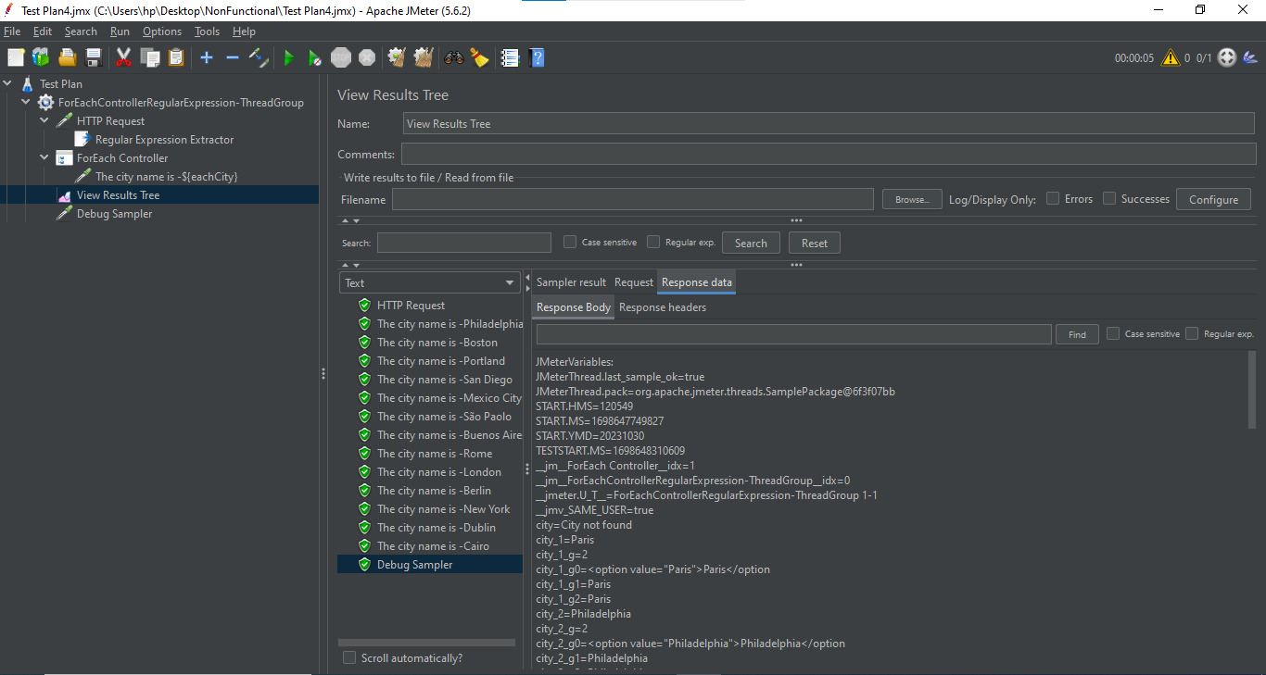

For Each Controller with Xpath Extractor:

Step1: Open Jmeter -> Add Thread Group

Step2: Right click on Thread Group -> Add -> Sampler -> HTTP request

Step3: In HTTP request, Give “https” as Protocol, Give “the-internet.herokuapp.com” as Server, Give “/” as Path

Step4: Right click on HTTP request -> Add -> Post Processors -> Xpath Extractor

Step5: In Xpath Extractor, Select the checkbox “Use Tidy” in XML Parsing options -> Give “nav” as Name of Created variable, Give “//*[@id="content"]/ul/li/a/@href” as Xpath query, Give “-1” as Match Number, Give “Not found” as Default value

Step6: Right click on Thread Group -> Add -> Logic Controller -> For Each Controller

Step7: In For Each Controller, Give “nav” as Input variable prefix, Give “navlinks” as Output variable name

Step8: Right click on For Each Controller -> Add -> Sampler -> HTTP request

Step9: In HTTP request, Give “https” as Protocol, Give “the-internet.herokuapp.com” as Server, Give “${navlinks}” as Path

Step10: Right click on Thread Group -> Add -> Listener -> View results tree (to see the output)

Step11: Right click on Thread Group -> Add -> Sampler -> Debug Sampler

